**Notes App Project: (Basic)**

In this project, you will create a web application to save the Notes. Working – The user will write the Title and note, which will be saved in the **Local storage** and displayed. Users can also **edit** and **delete** the note as per the requirement.

You need to create a **home page** consisting of the following things:

1. Header for the name of your app
2. Two Input-text boxes - Title and Note **(Only Title is mandatory)**
3. Button to add or save the note
4. Heading to show the notes **(A/T the availability of the notes)**

The page should look similar to this:

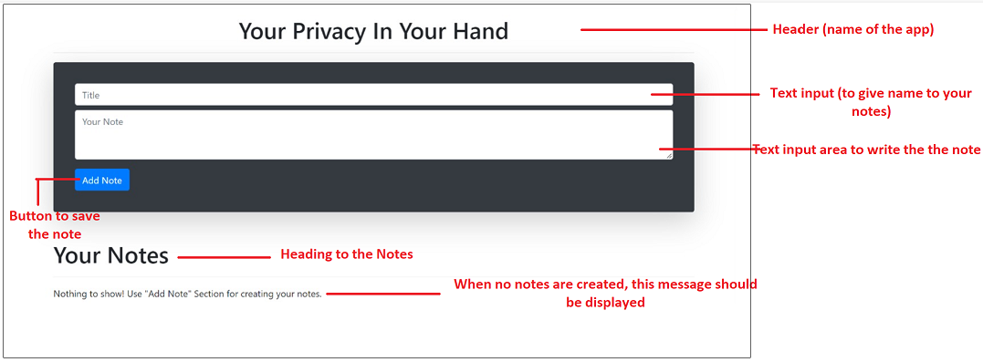

***#This image is for reference; we expect you to show your own design but all the mentioned functionality should be there.***